Upon determining the hardware dependencies for the reed switch inside the anemometer, the finalised circuitry of interfacing the anemometer with the microcontroller is depicted as follows.

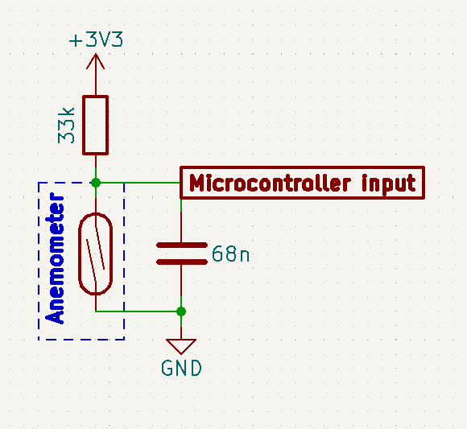

Figure 1. Anemometer-interfacing circuit